# Exploring Advanced Neural Networks: Teacher-Student Networks

Teacher-Student Networks, also known as Knowledge Distillation Networks, are a specialized architecture in neural networks where a larger, well-trained model (the teacher) transfers its knowledge to a smaller, more efficient model (the student). This approach is particularly valuable in scenarios requiring reduced computational resources, such as mobile applications and edge computing.

## 1. Introduction to the Neural Network

### Basic Components

A neural network consists of fundamental units called neurons, which are grouped into different layers:

* Input Layer: Receives raw data.
* Hidden Layers: Perform computations and feature extraction.
* Output Layer: Produces the final predictions based on processed information from hidden layers.

Each neuron is associated with weights and biases, which are adjusted during training to minimize prediction errors. Activation functions introduce non-linearity, enabling the network to learn complex patterns.

### Teacher-Student Network Architecture

In Teacher-Student Networks:

* Teacher Model: A large, complex neural network trained to achieve high accuracy on a given dataset.
* Student Model: A smaller, efficient network trained to replicate the teacher's performance while maintaining accuracy.

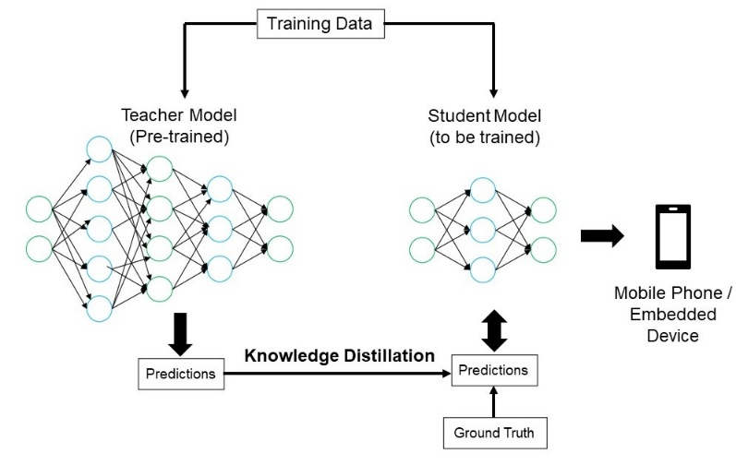

### What Makes It Unique?

Teacher-Student Networks are designed to transfer knowledge from a larger, well-trained network to a smaller one, making it highly useful for applications where computational efficiency is crucial, such as edge computing, mobile devices, and real-time AI processing.

## 2. Data and Learning

### Type of Data

Teacher-Student Networks can handle various data types depending on the domain:

* Image Data (e.g., classification tasks like CIFAR-10, ImageNet)
* Text Data (e.g., NLP tasks like sentiment analysis, text summarization)
* Audio Data (e.g., speech recognition)

### Learning Process

The learning process in a Teacher-Student Network involves:

1. Training the Teacher Model: A robust teacher model is first trained on the available dataset using standard deep learning techniques.
2. Generating Soft Targets: The teacher outputs probability distributions over possible classes, providing additional information about class relationships.
3. Training the Student Model: The student model is then trained using a mix of:
   * Ground truth labels.
   * The soft targets provided by the teacher.
4. Loss Function: A combination of Cross-Entropy Loss and Kullback-Leibler (KL) Divergence ensures the student model captures essential knowledge from the teacher's representation.

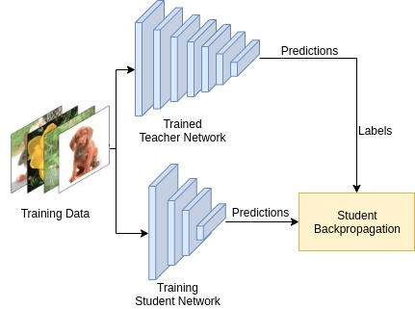

## 3. Transfer Learning and Pre-trained Models

### Concept of Transfer Learning

### Transfer learning involves taking a model that has been pre-trained on a large dataset and adapting it to a related task. In the context of Teacher-Student Networks, the student model leverages the teacher’s generalized understanding, making it easier to learn new tasks without starting from scratch.

### Advantages of Transfer Learning in Teacher-Student Networks

* Efficient Model Compression: This allows the deployment of complex models in environments with limited computational power.
* Reduced Training Time: The student model can converge more quickly than if it were trained from the ground up.
* Domain Adaptation: The student model can be further refined for a specific domain while still retaining the broad knowledge learned by the teacher.

### Use Cases of Teacher-Student Transfer Learning

* Mobile AI Applications: Compressing large models (like GPT or ResNet) for deployment on smartphones.
* Edge Computing: Reducing computational costs for real-time inference.
* Healthcare AI: Transferring knowledge from a large diagnostic model to a smaller, specialized model.

## Conclusion

Teacher-Student Networks offer a practical solution for deploying AI models efficiently while maintaining high performance. By distilling knowledge from a complex teacher model to a compact student model, they bridge the gap between accuracy and computational efficiency. The synergy of knowledge distillation and transfer learning makes them a powerful tool in deep learning applications.

## References

1. Hinton, G., Vinyals, O., & Dean, J. (2015). Distilling the Knowledge in a Neural Network.
2. Ba, L. J., & Caruana, R. (2014). Do Deep Nets Really Need to be Deep? Advances in Neural Information Processing Systems (NeurIPS).
3. Goyal, P., et al. (2021). Knowledge Distillation: A Survey. ACM Computing Surveys.